**RTU WEB VERSION 1.0**

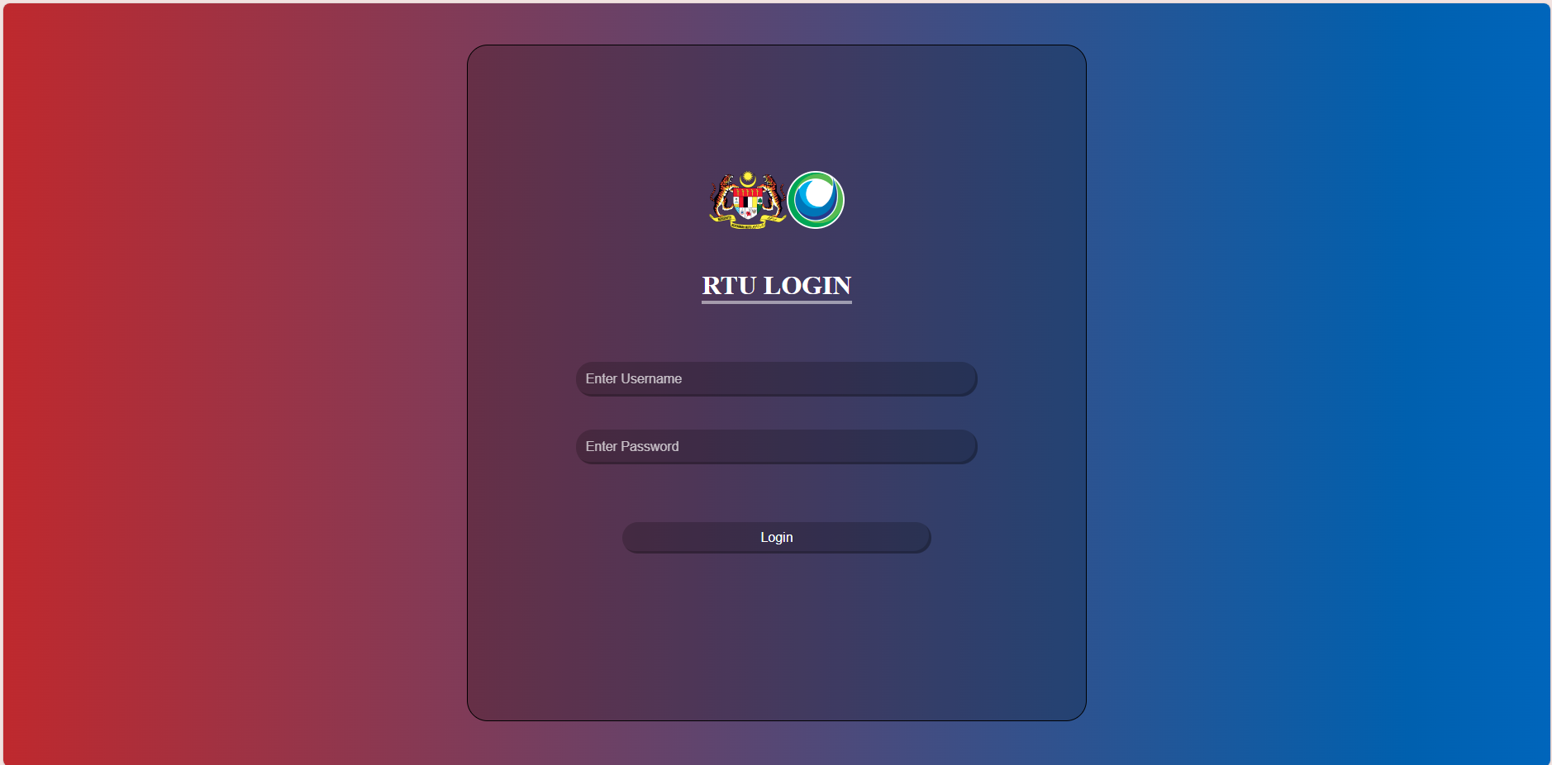

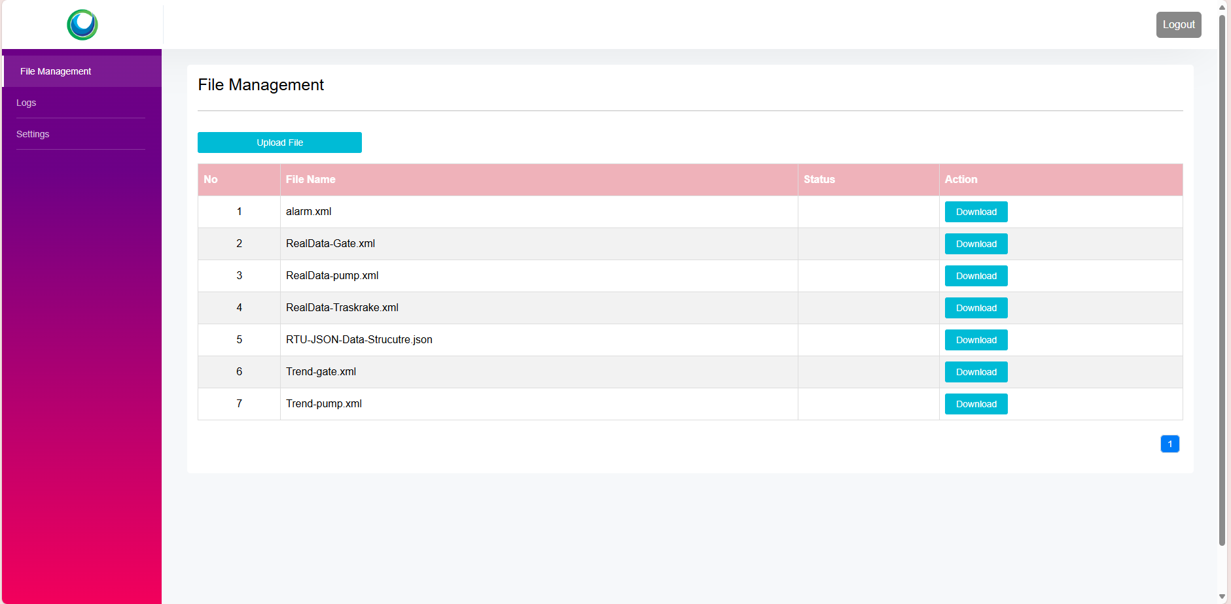

* **Set up guide:**

1. Node version v20.11.1
2. Npm version 10.2.4

* To run the program you can start with the following command:

1. Run “**npm install”** to install node modules
2. Run **“npm run dev”** to launch the program

→ the server will running on port 3001



* Folder structure

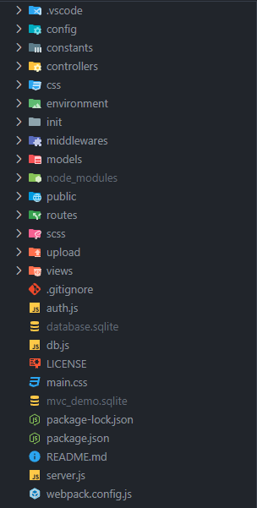

* RTU web is following MVC architecture, let’s dive into it.
* Constants folder:
* Containing global variables that access everywhere in your app: here you can change the rtu authentication, base url and port for web at the start up
* Containing cache. Basically A cache is a storage location where data can be stored for quick and easy access. Caches are used in a variety of applications, including computers, web browsers, and web servers.
* Controllers folder:
* Controller is a place where we put logic code in here including authentication, rtu settings, files,...
* Controller also contains an api folder that enables two software components to communicate with each other using a set of definitions and protocols.
* For example:

Mechis mobile app will call api from this folder to have access to RTU web to get files, or something like that.

* Css folder:
* Decorate the website
* Init folder:
* Including api like RtuV1/Login, RtuV1/GetSetting,...

→ The purpose of this is to handle the logic for Rtu. For example, auto running a job to send JSON file to MECHIS depending on the interval field of rtu setting, auto login if the current status code is 401, logging if users change some field of rtuSetting

* Middleware folder:
* Middleware is a request handler that allows you to intercept and manipulate requests and responses before they reach route handlers. They are the functions that are invoked by the Express. js routing layer.
* Models folder:
* This folder is to create database with tables:
* There are 4 main tables: File, Log, Rtu, User
* One Rtu can have multiple files, and logs
* Public folder:
* Where we put css files and icons
* Routes folder:
* A route is a section of Express code that associates an HTTP verb (GET, POST, PUT, DELETE, etc.), a URL path/pattern, and a function that is called to handle that pattern.
* Upload folder:
* Place that contains sample files that can send to Mechis, or to download it
* Views folder:
* Containing the view of the application.

Future Development Target:

* Adding configuration page for users with some new features
* Enable/ Disable auto send file,…
* Responsive for mobile view.